

Server Statistics

Nestle – Monthly Server Report

CONTACTS

 [**h.vanderburg@uppwise.com**](mailto:h.vanderburg@uppwise.com)

 [LinkedIn Company Profile](https://www.linkedin.com/company/uppwise)

www.uppwise.com

Table of Contents

2. Overall Progress SumApry 2

3. Server Utilization Statistics 2

3.1. Application Server 2

3.1.1. CPU 2

3.1.2. Memory 3

3.2. Database Server 3

3.2.1. PriMary DB Server 3

3.2.2. Secondary DB Server 4

4. USER LOGIN STATISTICS 6

5. Service Hours & Uptime 6

5.1. Outage – Approved & Planned 6

5.2. Non-Planned 7

5.3. Calculated Service Time 7

6. Support Status Overview 7

# Overall Progress SumApry

The following items are delivered or ready to be delivered:

|  |  |  |  |
| --- | --- | --- | --- |
| S. No. | Title | Status | Comments |
| 1 | #NIMT - ChangeManagement Completion | Done | on Preprod |
| 2 | Archive Switch | Done | on Preprod |
| 3 | New Workspace development | Done | on Prod |
| 4 | Workspace session management | Done | on Prod |
| 5 | Cost new structure | In Progress | on Preprod |

# Server Utilization Statistics

## Application Server

### CPU

The graph below shows the max utilization of CPU over the reported period, there is no service disrupting in application has counted in this period.

The below graph shows the average utilization of CPU over the reporting period, we can see that the average CPU utilization remains below 60%.

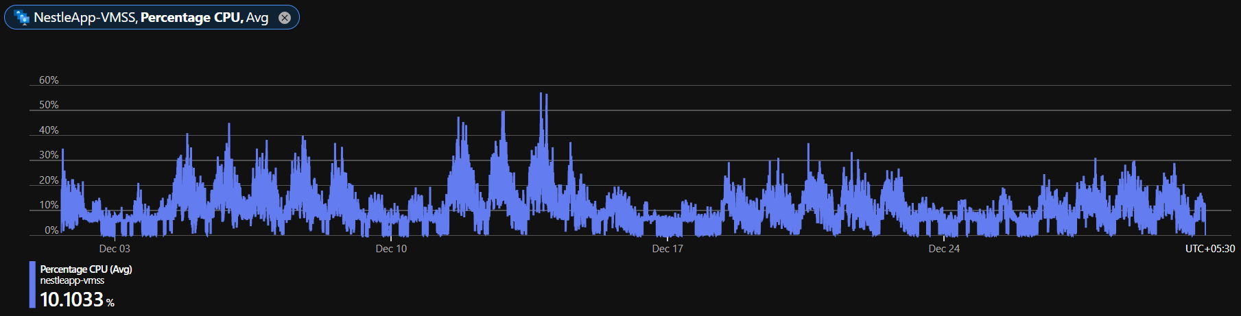

### Memory

Below is the Memory availability graph, it shows that almost 50 GB average memory remains available.

## Database Server

We have implemented the new infrastructure for databases with always on availability group and mirroring of the databases. In our Architecture now we have two servers, one is primary and the other is secondary, which split the load between these two.

Below graphs show the usage stats for each server separately.

### PriMary DB Server

3.2.1.1 CPU

The graph below is showing the max utilization of CPU over the reported period, we can see that after the scaling up of the servers there is quite good improvement in the utilization there is no service disrupting peak has counted in this period.

The below graph shows the average utilization of CPU over the reporting period, we can see that after the scaling up of the servers there is quite good improvement in the utilization the average CPU utilization is around 22%.

* + - 1. Memory

Below is the Memory availability graph, it shows that almost 27 GB memory remains available. Memory utilization is also improving much after resizing.

### Secondary DB Server

3.2.2.1 CPU

This is secondary database server, the pick showing in below graph is max value on a regular time when PowerBI publish and refresh, the secondary server does not have any impact on NIMT performance as the NIMT run from primary server. However, we can see that after the scaling up of the servers there is quite good improvement in the utilization.

The below graph is showing the average utilization of CPU over the reporting period, we can see that the average CPU utilization remain to average 6%, the peaks are of during the time of publish process, the secondary server does not have any impact on NIMT performance as the NIMT run from primary server.

3.2.2.2 Memory

Below is the Memory availability graph, it shows that almost 4GB memory remains available. We have added SQL server properties to hold maximum memory unless others resource required it therefore memory utilization is seen to be consumed more in graph.

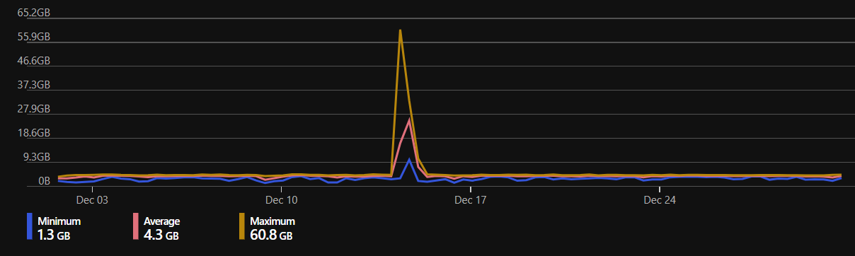

# USER LOGIN STATISTICS

Below is the graph of user login with the reporting period

* Total nr of login: ~ 70974
* Total distinct user login: ~ 2777.

Last month, the number of distinct logins was….

The total number of logins per day is …….

# Service Hours & Uptime

## Outage – Approved & Planned

**05 Sep 2023: -20 Minute**

This outage was taken to update Multi browser tab support and New Gantt - Planned  
**06 OCT 2023: -45 Minute**

This outage was taken to update support requests - Planned  
**11 OCT 2023: -20 Minute**

This outage was taken to update support requests – Planned  
**31 OCT 2023: -20 Minute**

This outage was taken to update support requests - Planned  
  
  
We see there are some pages is not loading for certain time specifically in the GMT midnight, and we are working on it to get this resolved very soon.

## Non-Planned

No non-planned outages reported this month

## Calculated Service Time

Period : *state 1st and last day of period=nr of days*

Total approved service time is 06 hours standard + xx hours= for additional approved downtime. (yy)

Required service time = nr of days * 24 – yy hours of available maintenance time=aa

Total uptime : nr of days * 24 – (real downtime) = aa- rd =bb

Service Uptime = MIN(738, 738) / 738 = **100%**

# Support Status Overview

A total of 52 tickets are recorded in October  
At the end of October, there are 2 tickets remaining open.